Randall C. Crawford
Student ID: 901012194
Email: r.crawford2194@student.nu.edu
Course: ANA 615 Data Mining Techniques

# Import required packages for this assignment.
from pathlib import Path
import math
import pandas as pd
from sklearn.model_selection import train_test_split
from sklearn.linear_model import LinearRegression
from sklearn.metrics import accuracy_score, roc_curve, auc
import matplotlib.pylab as plt
from dmba import regressionSummary, classificationSummary
from dmba import liftChart, gainsChart
from pathlib import Path
import pandas as pd
import numpy as np
from sklearn.decomposition import PCA
from sklearn import preprocessing
import matplotlib.pylab as plt
import seaborn as sns
%matplotlib inline
# **Problem 5.1 (pg. 155)**
# A data mining routine has been applied to a transaction dataset and has classified 88 records as fraudulent (30 correctly so) and 952 as non-fraudulent (920 correctly so). Construct the confusion matrix and calculate the overall error rate.
# Answer:
# Theoretical Classification Confusion Matrix
#|-----------------------------------------------------------------------------------------|
#| | Predicted Class |
#|-----------------------------------------------------------------------------------------|
#| Actual Class | C0 | C1 |
#|-----------------------------------------------------------------------------------------|
#| C0 | n0,0 = number of correctly | n0,1 = number of C0 cases |
#| | classified C0 cases | incorrectly classified as C1 |
#|-----------------------------------------------------------------------------------------|
#| C1 | n1,0 = number of C1 cases | n1,1 = number of correctly |
#| | incorrectly classified as C0 | classified C1 cases |
#|-----------------------------------------------------------------------------------------|
# Applied Classification Confusion Matrix
#|-----------------------------------------------------------------------|
#| | Predicted Class |
#|-----------------------------------------------------------------------|
#| Actual Class | Fraudulent (1) | Non-fraudulent (0) |
#|-----------------------------------------------------------------------|
#| Fraudulent (1) | 30 | 32 |
#|-----------------------------------------------------------------------|
#| Non-fraudulent (0) | 58 | 920 |
#|-----------------------------------------------------------------------|
# Formula For Overall Error Rate:
# Overall Error Rate = (n0,1 + n1,0)/ n, where n is the total number of records.
# Overall Error Rate Code For Problem 5.1:
overall_error_rate = (32 + 58) / 1040
overall_error_rate
0.08653846153846154
# Code Output Interpretation For Problem 5.1: The overall error rate was 8.65%.

# **Problem 5.2 (pg. 155)**
# Suppose that this routine has an adjustable cutoff (threshold) mechanism by which you can alter the proportion of records classified as fraudulent.
# *5.2.a. Describe how moving the cutoff up or down would affect the classification error rate for records that are truly fraudulent.*
# *5.2.b. Describe how moving the cutoff up or down would affect the classification error rate for records that are truly non-fraudulent.*
# Answer:
# Classification Confusion Matrix
#|----------------------------------------------------------------------|
#| | Predicted Class |
#|----------------------------------------------------------------------|
#| Actual Class | Fraudulent (1) | Non-fraudulent (0) |
#|----------------------------------------------------------------------|
#| Fraudulent (1) | a | b |
#|----------------------------------------------------------------------|
#| Non-fraudulent (0) | c | d |
#|----------------------------------------------------------------------|
# The classification error rate for truly fraudulent records (with this 0.5 cutoff) is b/(a+b).
# The classification error rate for truly non-fraudulent records (with this 0.5 cutoff) is c/(c+d).
# Increasing the cutoff above 0.5 leads to classifying more records, both fraudulent and non-fraudulent, as non-fraudulent: b and d both increase, a and c decline.
# a. With respect to the classification error rate for truly fraudulent records, the error rate, b/(a+b), increases as b goes up. As you raise the standard for calling a record fraudulent, you miss more and more of the real frauds.
# b. With respect to the classification error rate for truly non-fraudulent records, the error rate, c/(c+d), decreases as d goes up. As you raise the standard for calling a record fraudulent, fewer non-frauds get mislabeled as frauds.

# **Problem 5.5 (pg. 156)**
# A large number of insurance records are to be examined to develop a model for predicting fraudulent claims. Of the claims in the historical database, 1% were judged to be fraudulent. A sample is taken to develop a model, and oversampling is used to provide a balanced sample in light of the very low response rate. When applied to this sample (n = 800), the model ends up correctly classifying 310 frauds, and 270 nonfrauds. It missed 90 frauds, and classified 130 records incorrectly as frauds when they were not.
# *5.5.a. Produce the confusion matrix for the sample as it stands.*
# Answer:
# Classification Confusion Matrix
#|------------------------------------------------|
#| | Predicted Class |
#|------------------------------------------------|
#| Actual Class | 1 | 0 |
#|------------------------------------------------|
#| 1 | 310 | 90 |
#|------------------------------------------------|
#| 0 | 130 | 270 |
#|------------------------------------------------|
# Misclassification Rate Code For Problem 5.5.a
misclassification_rate = (90 + 130) / 800
misclassification_rate
0.275
# Code Output Interpretation For Problem 5.5.a: The overall misclassification rate was 27.5%.
# The model ends up classifying (310 + 130) / 800 = 0.55 = 55% of the records as fraudulent.
# *5.5.b. Find the adjusted misclassification rate (adjusting for the oversampling).*
# Answer:
# Now we need to add enough zeros, so that the 1's only constitute 1% of the total and the 0's constitute 99% of the total (where x is the total).
# 400 + 0.99 * x = x
# Therefore x = 40,000
# Number of zeros = 0.99 * 40,000 = 39,600
# Classification Confusion Matrix
#|-------------------------------------------------------------|
#| | Predicted Class | |
#|-------------------------------------------------------------|
#| Actual Class | 1 | 0 | Total |
#|-------------------------------------------------------------|
#| 1 | 310 | 90 | 400 |
#|-------------------------------------------------------------|
#| 0 | 12,870 | 26,730 | 39,600 |
#|-------------------------------------------------------------|
#| Total | 13,180 | 26,820 | 40,000 |
#|-------------------------------------------------------------|
# Adjusted Misclassification Rate Code For Problem 5.5.b:
adj_misclassification_rates = (90 + 12870) / 40000
adj_misclassification_rates
0.324
# Code Output Interpretation For Problem 5.5.b: The adjusted misclassification rate was 32.4%.

# *5.5.c. What percentage of new records would you expect to be classified as fraudulent?*
# The model ends up classifying (310 + 12,870) / 40,000 = 0.3295 = 32.95% of the records as fraudulent.

# **Problem 5.7 (pg. 157)**
# Table 5.7 shows a small set of predictive model validation results for a classification model, with both actual values and propensities.
# *5.7.a. Calculate error rates, sensitivity, and specificity using cutoffs of 0.25, 0.5, and 0.75.*
# Create a data frame from Table 5.7 data.
data = {'Propensity': [0.03, 0.52, 0.38, 0.82, 0.33, 0.42, 0.55, 0.59, 0.09, 0.21, 0.43, 0.04, 0.08, 0.13, 0.01, 0.79, 0.42,
0.29, 0.08, 0.02],
'Actual': [0, 0, 0, 1, 0, 0, 1, 0, 0, 0, 0, 0, 0, 0, 0, 1, 0, 0, 0, 0]}
# Convert to data frame.
df = pd.DataFrame(data)

# Cutoff = 0.25
Predicted = [1 if p > 0.25 else 0 for p in df.Propensity]
classificationSummary(df.Actual, Predicted, class_names=['0', '1'])
Confusion Matrix (Accuracy 0.6000)
Prediction
Actual 0 1
0 9 8
1 0 3
# Overall Error Rate (with 0.25 cutoff)
error_rate = (8) / 20
print('\nError Rate = ', error_rate)
# Sensitivity (with 0.25 cutoff)
sensitivity = (3) / (3+0)
print('\nSensitivity=',sensitivity)
# Specificity (with 0.25 cutoff)
specificity = (9) / (8+9)
print('\nSpecificity = ', specificity)
Error Rate = 0.4
Sensitivity= 1.0
Specificity = 0.5294117647058824

# Cutoff = 0.5
Predicted = [1 if p > 0.5 else 0 for p in df.Propensity]
classificationSummary(df.Actual, Predicted, class_names=['0', '1'])
Confusion Matrix (Accuracy 0.9000)
Prediction
Actual 0 1
0 15 2
1 0 3
# Overall Error Rate (with 0.5 cutoff)
error_rate = (2) / 20
print('\nError Rate = ', error_rate)
# Sensitivity (with 0.5 cutoff)
sensitivity = (3) / (3+0)
print('\nSensitivity=',sensitivity)
# Specificity (with 0.5 cutoff)
specificity = (15) / (2+15)
print('\nSpecificity = ', specificity)
Error Rate = 0.1
Sensitivity= 1.0
Specificity = 0.8823529411764706

# Cutoff = 0.75
Predicted = [1 if p > 0.75 else 0 for p in df.Propensity]
classificationSummary(df.Actual, Predicted, class_names=['0', '1'])
Confusion Matrix (Accuracy 0.9500)
Prediction
Actual 0 1
0 17 0
1 1 2
# Overall Error Rate (with 0.75 cutoff)
error_rate = (1) / 20
print('\nError Rate = ', error_rate)
# Sensitivity (with 0.75 cutoff)
sensitivity = (2) / (2+1)
print('\nSensitivity=',sensitivity)
# Specificity (with 0.75 cutoff)
specificity = (17) / (0+17)
print('\nSpecificity = ', specificity)
Error Rate = 0.05
Sensitivity= 0.6666666666666666
Specificity = 1.0

# *5.7.b. Create a decile lift chart.*
# Sort data by propensities.
df = df.sort_values(by=['Propensity'], ascending=False)
# Generate decile lift chart.
liftChart(df.Actual)
plt.show()
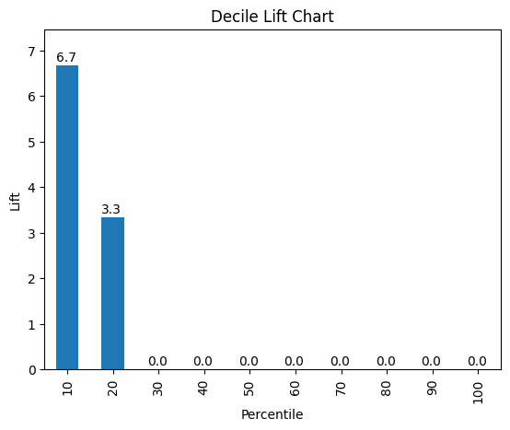

# **4.8 Principal Components Analysis - Example 2: Breakfast Cereals**
# Load required data.
cereals_df = pd.read_csv('Course Data/dmba/Cereals.csv')
# Show the data frame.
cereals_df
name mfr type calories protein fat sodium fiber
0 100%_Bran N C 70 4 1 130 10.0
1 100%_Natural_Bran Q C 120 3 5 15 2.0
2 All-Bran K C 70 4 1 260 9.0
3 All-Bran_with_Extra_Fiber K C 50 4 0 140 14.0
4 Almond_Delight R C 110 2 2 200 1.0
.. ... .. ... ... ... ... ... ...
72 Triples G C 110 2 1 250 0.0
73 Trix G C 110 1 1 140 0.0
74 Wheat_Chex R C 100 3 1 230 3.0
75 Wheaties G C 100 3 1 200 3.0
76 Wheaties_Honey_Gold G C 110 2 1 200 1.0
carbo sugars potass vitamins shelf weight cups rating
0 5.0 6.0 280.0 25 3 1.0 0.33 68.402973
1 8.0 8.0 135.0 0 3 1.0 1.00 33.983679
2 7.0 5.0 320.0 25 3 1.0 0.33 59.425505
3 8.0 0.0 330.0 25 3 1.0 0.50 93.704912
4 14.0 8.0 NaN 25 3 1.0 0.75 34.384843
.. ... ... ... ... ... ... ... ...
72 21.0 3.0 60.0 25 3 1.0 0.75 39.106174
73 13.0 12.0 25.0 25 2 1.0 1.00 27.753301
74 17.0 3.0 115.0 25 1 1.0 0.67 49.787445
75 17.0 3.0 110.0 25 1 1.0 1.00 51.592193
76 16.0 8.0 60.0 25 1 1.0 0.75 36.187559
[77 rows x 16 columns]

# **PCA On The Two Variables Calories And Rating - TABLE 4.11**
# Code For Running PCA
pcs = PCA(n_components=2)
pcs.fit(cereals_df[['calories', 'rating']])
PCA(n_components=2)
# The importance of components can be assessed using the explained variance.
# pcsSummary
pcsSummary = pd.DataFrame({'Standard deviation': np.sqrt(pcs.explained_variance_),
'Proportion of variance': pcs.explained_variance_ratio_,
'Cumulative proportion': np.cumsum(pcs.explained_variance_ratio_)})
pcsSummary = pcsSummary.transpose()
pcsSummary.columns = ['PC1', 'PC2']
pcsSummary.round(4)
PC1 PC2
Standard deviation 22.3165 8.8844
Proportion of variance 0.8632 0.1368
Cumulative proportion 0.8632 1.0000
# The `components_` field of `pcs` gives the individual components. The columns in this matrix are the principal components `PC1`, `PC2`. The rows are variables in the order they are found in the input matrix, `calories` and `rating`.
# Components
pcsComponents_df = pd.DataFrame(pcs.components_.transpose(), columns=['PC1', 'PC2'],
index=['calories', 'rating'])
pcsComponents_df
PC1 PC2
calories 0.847053 0.531508
rating -0.531508 0.847053
# Use the `transform` method to get the scores.
# Scores
scores = pd.DataFrame(pcs.transform(cereals_df[['calories', 'rating']]),
columns=['PC1', 'PC2'])
scores.head()
PC1 PC2
0 -44.921528 2.197183
1 15.725265 -0.382416
2 -40.149935 -5.407212
3 -75.310772 12.999126
4 7.041508 -5.357686

# **PCA Output Using All 13 Numerical Variables In The Breakfast Cereal Dataset - TABLE 4.12**
# pcsSummary
pcs = PCA()
pcs.fit(cereals_df.iloc[:, 3:].dropna(axis=0))
pcsSummary_df = pd.DataFrame({'Standard deviation': np.sqrt(pcs.explained_variance_),
'Proportion of variance': pcs.explained_variance_ratio_,
'Cumulative proportion': np.cumsum(pcs.explained_variance_ratio_)})
pcsSummary_df = pcsSummary_df.transpose()
pcsSummary_df.columns = ['PC{}'.format(i) for i in range(1, len(pcsSummary_df.columns) + 1)]
pcsSummary_df.round(4)
PC1 PC2 PC3 PC4 PC5 PC6
Standard deviation 83.7641 70.9143 22.6437 19.1815 8.4232 2.0917
Proportion of variance 0.5395 0.3867 0.0394 0.0283 0.0055 0.0003
Cumulative proportion 0.5395 0.9262 0.9656 0.9939 0.9993 0.9997
PC7 PC8 PC9 PC10 PC11 PC12 PC13
Standard deviation 1.6994 0.7796 0.6578 0.3704 0.1864 0.063 0.0
Proportion of variance 0.0002 0.0000 0.0000 0.0000 0.0000 0.000 0.0
Cumulative proportion 0.9999 1.0000 1.0000 1.0000 1.0000 1.000 1.0
# Generate table that shows results for the first five principal components.
pcsComponents_df = pd.DataFrame(pcs.components_.transpose(), columns=pcsSummary_df.columns,
index=cereals_df.iloc[:, 3:].columns)
pcsComponents_df.iloc[:,:5]
PC1 PC2 PC3 PC4 PC5
calories 0.077984 -0.009312 0.629206 -0.601021 0.454959
protein -0.000757 0.008801 0.001026 0.003200 0.056176
fat -0.000102 0.002699 0.016196 -0.025262 -0.016098
sodium 0.980215 0.140896 -0.135902 -0.000968 0.013948
fiber -0.005413 0.030681 -0.018191 0.020472 0.013605
carbo 0.017246 -0.016783 0.017370 0.025948 0.349267
sugars 0.002989 -0.000253 0.097705 -0.115481 -0.299066
potass -0.134900 0.986562 0.036782 -0.042176 -0.047151
vitamins 0.094293 0.016729 0.691978 0.714118 -0.037009
shelf -0.001541 0.004360 0.012489 0.005647 -0.007876
weight 0.000512 0.000999 0.003806 -0.002546 0.003022
cups 0.000510 -0.001591 0.000694 0.000985 0.002148
rating -0.075296 0.071742 -0.307947 0.334534 0.757708

# **PCA Output Using All Normalized 13 Variables In The Breakfast Cereal Dataset - TABLE 4.13**
# Normalized pcsSummary
pcs = PCA()
pcs.fit(preprocessing.scale(cereals_df.iloc[:, 3:].dropna(axis=0)))
pcsSummary_df = pd.DataFrame({'Standard deviation': np.sqrt(pcs.explained_variance_),
'Proportion of variance': pcs.explained_variance_ratio_,
'Cumulative proportion': np.cumsum(pcs.explained_variance_ratio_)})
pcsSummary_df = pcsSummary_df.transpose()
pcsSummary_df.columns = ['PC{}'.format(i) for i in range(1, len(pcsSummary_df.columns) + 1)]
pcsSummary_df.round(4)
PC1 PC2 PC3 PC4 PC5 PC6
Standard deviation 1.9192 1.7864 1.3912 1.0166 1.0015 0.8555
Proportion of variance 0.2795 0.2422 0.1469 0.0784 0.0761 0.0555
Cumulative proportion 0.2795 0.5217 0.6685 0.7470 0.8231 0.8786
PC7 PC8 PC9 PC10 PC11 PC12 PC13
Standard deviation 0.8251 0.6496 0.5658 0.3051 0.2537 0.1399 0.0
Proportion of variance 0.0517 0.0320 0.0243 0.0071 0.0049 0.0015 0.0
Cumulative proportion 0.9303 0.9623 0.9866 0.9936 0.9985 1.0000 1.0
# Generate table that shows results for the first five principal components.
pcsComponents_df = pd.DataFrame(pcs.components_.transpose(), columns=pcsSummary_df.columns,
index=cereals_df.iloc[:, 3:].columns)
pcsComponents_df.iloc[:,:5]
PC1 PC2 PC3 PC4 PC5
calories -0.299542 0.393148 0.114857 -0.204359 0.203899
protein 0.307356 0.165323 0.277282 -0.300743 0.319749
fat -0.039915 0.345724 -0.204890 -0.186833 0.586893
sodium -0.183397 0.137221 0.389431 -0.120337 -0.338364
fiber 0.453490 0.179812 0.069766 -0.039174 -0.255119
carbo -0.192449 -0.149448 0.562452 -0.087835 0.182743
sugars -0.228068 0.351434 -0.355405 0.022707 -0.314872
potass 0.401964 0.300544 0.067620 -0.090878 -0.148360
vitamins -0.115980 0.172909 0.387859 0.604111 -0.049287
shelf 0.171263 0.265050 -0.001531 0.638879 0.329101
weight -0.050299 0.450309 0.247138 -0.153429 -0.221283
cups -0.294636 -0.212248 0.140000 -0.047489 0.120816
rating 0.438378 -0.251539 0.181842 -0.038316 0.057584

# Using principal components for classification and prediction, generate scatterplot of the second vs. first principal component scores for the normalized breakfast cereal output.
from adjustText import adjust_text
cereals_red_df = cereals_df.dropna(axis=0)
cereals_red_df = cereals_red_df.reset_index(drop=True)
scores = pd.DataFrame(pcs.fit_transform(preprocessing.scale(cereals_red_df.iloc[:, 3:].dropna(axis=0))),
columns=[f'PC{i}' for i in range(1, 14)])
cereals_pca_df = pd.concat([cereals_red_df['name'].dropna(axis=0), scores[['PC1', 'PC2']]], axis=1)
ax = cereals_pca_df.plot.scatter(x='PC1', y='PC2', figsize=(6, 6))
points = cereals_pca_df[['PC1','PC2','name']]
texts = []
for _, (x, y, s) in points.iterrows():
texts.append(ax.text(x, y, s))
adjust_text(texts, force_text=0.05, arrowprops=dict(arrowstyle="-|>", color='r', alpha=0.5))
plt.show()
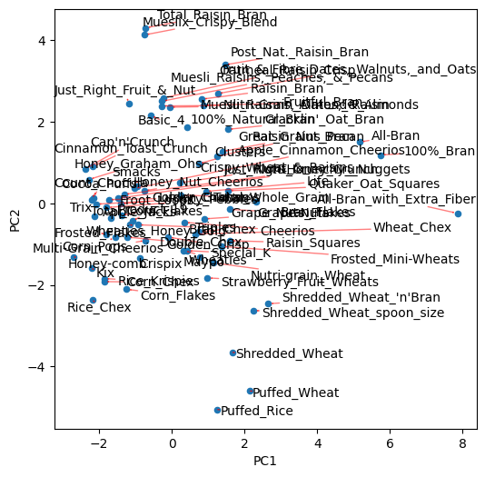
# Using principal components for classification and prediction with kmeans cluster reduction, generate scatterplot of the second vs. first principal component scores for the normalized breakfast cereal output.
from sklearn.cluster import KMeans
cereals_pca_df = pd.concat([cereals_df['name'], scores], axis=1) #ignore_index=True)
ax = cereals_pca_df.plot.scatter(x='PC1', y='PC2', figsize=(8, 12))
points = pd.DataFrame(points)
def extractPoint(df, texts):
for _, (x, y, s) in df.sample(1)[['PC1','PC2','name']].iterrows():
texts.append(ax.text(x, y, s))
kmeans = KMeans(n_clusters=20, random_state=0).fit(points[['PC1', 'PC2']])
points['cluster'] = kmeans.labels_
texts = []
points.groupby(['cluster']).apply(lambda g: extractPoint(g, texts))
adjust_text(texts, force_text=0.05, arrowprops=dict(arrowstyle="-|>", color='grey', alpha=0.5))
plt.show()
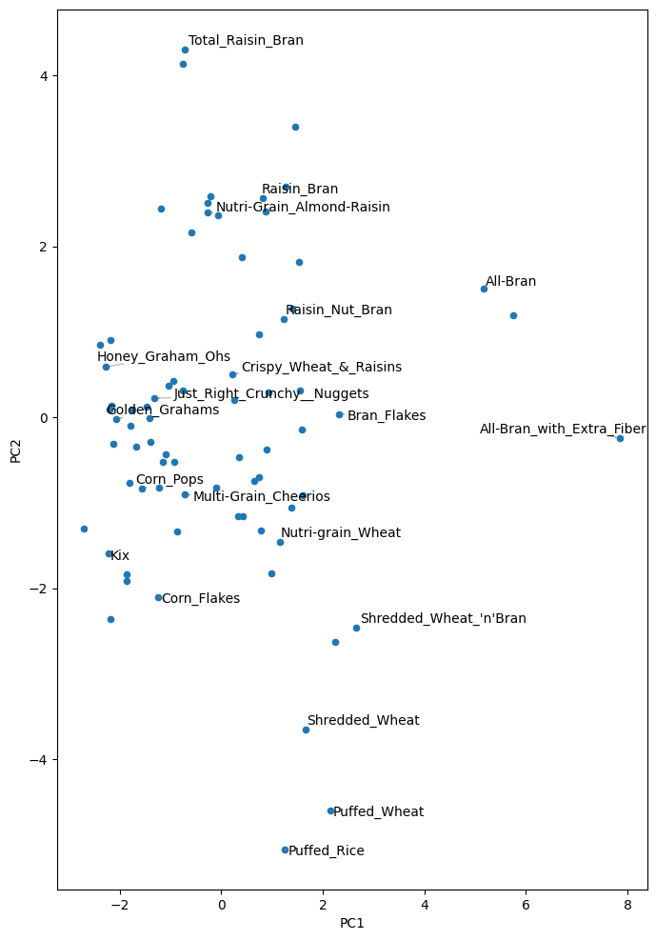
# **Problem 4.3 (pg. 120) - Sales Of Toyota Corolla Cars**
# The file _ToyotaCorolla.csv_ contains data on used cars (Toyota Corollas) on sale during late summer of 2004 in the Netherlands. It has 1436 records containing details on 38 attributes, including Price, Age, Kilometers, HP, and other specifications. The goal will be to predict the price of a used Toyota Corolla based on its specifications.
# *4.3.a Identify the categorical variables.*
# Load the required data.
toyota_df = pd.read_csv('Course Data/dmba/ToyotaCorolla.csv')
# Find the dimensions of the data frame.
toyota_df.shape
(1436, 39)
# List variable types.
toyota_df.dtypes
Id int64
Model object
Price int64
Age_08_04 int64
Mfg_Month int64
Mfg_Year int64
KM int64
Fuel_Type object
HP int64
Met_Color int64
Color object
Automatic int64
CC int64
Doors int64
Cylinders int64
Gears int64
Quarterly_Tax int64
Weight int64
Mfr_Guarantee int64
BOVAG_Guarantee int64
Guarantee_Period int64
ABS int64
Airbag_1 int64
Airbag_2 int64
Airco int64
Automatic_airco int64
Boardcomputer int64
CD_Player int64
Central_Lock int64
Powered_Windows int64
Power_Steering int64
Radio int64
Mistlamps int64
Sport_Model int64
Backseat_Divider int64
Metallic_Rim int64
Radio_cassette int64
Parking_Assistant int64
Tow_Bar int64
dtype: object
# Categorical Variables
# Fuel_Type Fuel Type (Petrol, Diesel, CNG)
# Color Color (Blue, Red, Grey, Silver, Black, etc.)
# Met_Color Metallic Color? (Yes=1, No=0)
# Automatic Automatic ( (Yes=1, No=0)
# Mfr_Guarantee Within Manufacturer's Guarantee period (Yes=1, No=0)
# BOVAG_Guarantee BOVAG (Dutch dealer network) Guarantee (Yes=1, No=0)
# ABS Anti-Lock Brake System (Yes=1, No=0)
# Airbag_1 Driver_Airbag (Yes=1, No=0)
# Airbag_2 Passenger Airbag (Yes=1, No=0)
# Airco Airconditioning (Yes=1, No=0)
# Automatic_airco Automatic Airconditioning (Yes=1, No=0)
# Boardcomputer Boardcomputer (Yes=1, No=0)
# CD_Player CD Player (Yes=1, No=0)
# Central_Lock Central Lock (Yes=1, No=0)
# Powered_Windows Powered Windows (Yes=1, No=0)
# Power_Steering Power Steering (Yes=1, No=0)
# Radio Radio (Yes=1, No=0)
# Mistlamps Mistlamps (Yes=1, No=0)
# Sport_Model Sport Model (Yes=1, No=0)
# Backseat_Divider Backseat Divider (Yes=1, No=0)
# Metallic_Rim Metallic Rim (Yes=1, No=0)
# Radio_cassette Radio Cassette (Yes=1, No=0)
# Parking_Assistant Parking assistance system (Yes=1, No=0)
# Tow_Bar Tow Bar (Yes=1, No=0)

# *4.3.b. Explain the relationship between a categorical variable and the series of binary dummy variables derived from it.*
# A variable with N categories will be transformed into N dummy variables, with each dummy indicating whether a certain category is present or not. For example, fuel type has 3 categories: Petrol, Diesel, and CNG. If we convert it to dummy variables, we get 3 dummy variables: Fuel_Type_Petrol (if the fuel type is Petrol then Fuel_Type_Petrol=1, otherwise Fuel_Type_Petrol=0), Fuel_Type_Diesel (if the fuel type is Diesel then Fuel_Type_Diesel=1, otherwise Fuel_Type_Diesel=0) and Fuel_Type_CNG (if the fuel type is CNG then Fuel_Type_CNG=1, otherwise Fuel_Type_CNG=0). Note that when the first two dummies both have values of 0, it indicates that the fuel type is CNG.

# *4.3.c. How many dummy binary variables are required to capture the information in a categorical variable with N categories?*
# N-1 binary variables are required to capture the information in a categorical variable with N categories. Note that in some routines, e.g. linear regression and logistic regression, use of all N dummies will cause the routine to fail because the nth variable contains redundant information and can be expressed as a linear combination of the others. Only N-1 variables should be used (they contain all the available information about the variable from which they were derived).

# *4.3.d. Use Python to convert the categorical variables in this dataset into dummy variables, and explain in words, for one record, the values in the derived binary dummies.*
# When we convert Fuel type into dummy variables, we get Fuel_Type_Diesel, Fuel_Type_Petrol and Fuel_Type_CNG. For the 1st record Fuel type is Diesel. Values in dummy variables are as follows: Fuel_Type_Diesel = 1, Fuel_Type_Petrol = 0, Fuel_Type_CNG = 0.
# Create dummy variables for Fuel_Type.
df_fuel_type = pd.get_dummies(toyota_df['Fuel_Type'])
# Append new dummy variables to the original data set.
new_df = pd.concat([toyota_df, df_fuel_type], axis=1)

# Note: That not all 42 variables are shown in the output showing some initial observations below.
# Show first five records in new data set.
new_df.head()
Id Model Price Age_08_04
0 1 TOYOTA Corolla 2.0 D4D HATCHB TERRA 2/3-Doors 13500 23
1 2 TOYOTA Corolla 2.0 D4D HATCHB TERRA 2/3-Doors 13750 23
2 3 TOYOTA Corolla 2.0 D4D HATCHB TERRA 2/3-Doors 13950 24
3 4 TOYOTA Corolla 2.0 D4D HATCHB TERRA 2/3-Doors 14950 26
4 5 TOYOTA Corolla 2.0 D4D HATCHB SOL 2/3-Doors 13750 30
Mfg_Month Mfg_Year KM Fuel_Type HP Met_Color ... Mistlamps
0 10 2002 46986 Diesel 90 1 ... 0
1 10 2002 72937 Diesel 90 1 ... 0
2 9 2002 41711 Diesel 90 1 ... 0
3 7 2002 48000 Diesel 90 0 ... 0
4 3 2002 38500 Diesel 90 0 ... 1
Sport_Model Backseat_Divider Metallic_Rim Radio_cassette
0 0 1 0 0
1 0 1 0 0
2 0 1 0 0
3 0 1 0 0
4 0 1 0 0
Parking_Assistant Tow_Bar CNG Diesel Petrol
0 0 0 False True False
1 0 0 False True False
2 0 0 False True False
3 0 0 False True False
4 0 0 False True False
[5 rows x 42 columns]

# *4.3.e. Use Python to produce a correlation matrix and matrix plot. Comment on the relationships among variables.*
# Generate correlation matrix.
corr_df = new_df[['Price', 'Age_08_04', 'KM', 'HP', 'CC', 'Quarterly_Tax', 'Weight']]
corr = corr_df.corr()
corr
Price Age_08_04 KM HP CC
Price 1.000000 -0.876590 -0.569960 0.314990 0.126389
Age_08_04 -0.876590 1.000000 0.505672 -0.156622 -0.098084
KM -0.569960 0.505672 1.000000 -0.333538 0.102683
HP 0.314990 -0.156622 -0.333538 1.000000 0.035856
CC 0.126389 -0.098084 0.102683 0.035856 1.000000
Quarterly_Tax 0.219197 -0.198431 0.278165 -0.298432 0.306996
Weight 0.581198 -0.470253 -0.028598 0.089614 0.335637
Quarterly_Tax Weight
Price 0.219197 0.581198
Age_08_04 -0.198431 -0.470253
KM 0.278165 -0.028598
HP -0.298432 0.089614
CC 0.306996 0.335637
Quarterly_Tax 1.000000 0.626134
Weight 0.626134 1.000000
# Generate correlation heatmap.
sns.heatmap(corr, xticklabels=corr.columns, yticklabels=corr.columns)
plt.show()
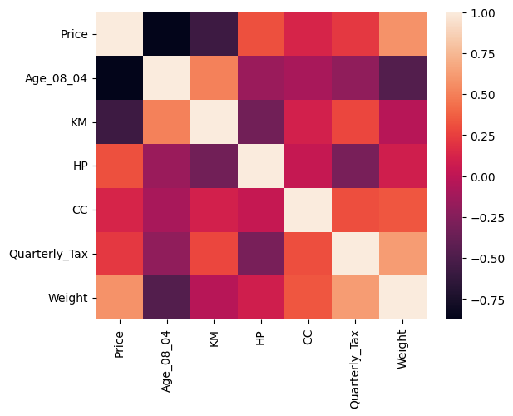
# Commentary #4.3.e
# Price has a strong negative correlation with Age_08_04. This makes sense, because the older the car is, the less it will cost. Price has a notable negative correlation with KM. This makes sense, because the more accumulated kilometers on the odometer, the less it will cost. Age_08_04 has a notable positive correlation with KM. This makes sense, because the older the car is, the more accumulated kilometers on the odometer. Weight has a notable positive correlation with Price and Quarterly_Tax. This makes sense, because the heavier the car is, the more it will cost and the more tax that could be assessed.

